

KABARAK UNIVERSITY

DEPARTMENT OF COMPUTER SCIENCE AND IT

PROJECT TITLE: ENHANCED FOLLOW-UP AND DISCEPLESHIP SYSTEM FOR THE DIGITAL AGE

TIMOTHY KIPNGENO CHUMO – INTE/MG/2660/09/22

A Project Proposal Submitted to the School of Science Engineering and Technology in Partial Fulfilment of the Requirements for the Award of a Degree of Bachelor of Science in Information Technology of Kabarak University.

AUGUST 2025

DECLARATION
I declare that this proposal is my original work and has not been previously published or submitted elsewhere for marking. I also declare that this work contains no material written or published by other people except where due reference is made and the author duly acknowledged.
TIMOTHY KIPNGENO CHUMO- INTE/MG/2660/09/22
SIGNATURE………………………. DATE ……………………
DR. ANDREW KEBUT
I confirm that the students carried out the work reported in this project under my supervision.
SIGNATURE…………………………… DATE……………..

RECOMMENDATION
This research project has been submitted for examination with my approval as the university supervisor
SIGNATURE: …………………. DATE: ……………………
NAME: DR. ANDREW KIPKEBUT
LECTURER: KABARAK UNIVERSITY

ACKNOWLEDGEMENT
I want to send my sincere gratitude to my supervisor Dr. Andrew Kipkebut for the time he dedicated to guiding me throughout developing this proposal. I would also like to thank my lecturers in the Department of Computer Science and Information Technology for the support they gave me during the development of this research. In addition to that, I send my sincere gratitude to the whole Kabarak University fraternity for giving me a conducive environment for my studies and the development of this proposal. Lastly, I would wish to extend my gratitude to my parents for the support to stay in school. Thank you all.

DEDICATION
I dedicate this work to my family, friends and my lecturer for giving me full support throughout the hard process of research, and also for providing conducive environment for the project.

LIST OF FIGURES
Figure 1: Concept Diagram ................................................................................................7
Figure 1: Context Diagram ................................................................................................12
Figure 2: Data Flow Diagram……….................................................................................13
Figure 3: Entity Relationship diagram................................................................................14
Figure 4: Use Case Diagram……………...........................................................................15
Figure 6: Class Diagram………….....................................................................................16
Figure 7: Sequence Diagram…………...............................................................................17
Figure 8: Activity Diagram ................................................................................................18

ABSTRACT
This project proposes the development of an Enhanced Follow-up and Discipleship system for the digital age, a web-based platform aimed at enhancing how churches follow up with new converts and manage discipleship for both new and existing members. The system is inspired by the ministry model of Jesus Christ and addresses common operational challenges faced by both small and large churches in Kenya. Currently, many churches rely on manual processes such as notebooks and verbal communication, which are inefficient and prone to error. These shortcomings contribute to high dropout rates, inconsistent discipleship, and limited pastoral oversight. The objectives of this study include identifying the current challenges in church-based discipleship, designing a system to manage class attendance and spiritual growth, integrating automated communication tools, and evaluating the system’s effectiveness in improving member engagement. The project will follow a mixed-method research design, incorporating both qualitative and quantitative approaches, and employ Agile software development methodology to ensure iterative testing and feedback. Key features of the system include member registration, discipleship class tracking, automated SMS/email reminders, and real-time reporting dashboards for church leaders. The expected outcomes are improved member retention, increased spiritual accountability, and streamlined pastoral care. This system seeks to bridge the gap between spiritual intention and digital implementation, ensuring that every believer is nurtured, monitored, and supported in their walk of faith.

TABLE OF CONTENTS
DECLARATION ii
RECOMMENDATION iii
ACKNOWLEDGEMENT iv
LIST OF FIGURES vi
ABSTRACT vii
CHAPTER ONE 1
INTRODUCTION 1
1.1 Introduction 1
1.2 Background of the Study 1
1.3 Problem Statement 2
1.4 Objectives 2
1.4.1 Main Objective 2
1.4.2 Specific Objectives 2
1.5 Research Questions 3
1.6 Significance of the Study 3
1.7 Scope and Limitations of the Study 4
CHAPTER TWO 5
LITERATURE REVIEW 5
2.1 Introduction 5
2.2 Review of Objective One: Challenges in Church-Based Follow-Up 5
2.3 Review of Objective Two: Digital Solutions for Discipleship Tracking 5
2.4 Review of Objective Three: Automating Communication and Class Management 6
2.5 Conceptual Framework 6
CHAPTER THREE 8
RESEARCH METHODOLOGY 8
3.1 Introduction 8
3.2 Research Methodology 8
3.3 Development Methodology 8
3.3.1 Development Approach 8
3.3.2 Iterative Process 9
3.4 Data Collection Methods 9
3.5 System Analysis and Design (SAD) 10
3.5.1 System Analysis 10
3.5.2 System Modeling 12
3.6 Research Ethics 20
3.7 REFERENCES 21
APPENDICES 22
APPENDIX A: SAMPLE QUESTIONNAIRE 22
APPENDIX B: INTERVIEW GUIDE 23
APPENDIX C : ESTIMATE BUDGET 24
APPENDIX D: WORK PLAN 25

CHAPTER ONE

INTRODUCTION

1.1 Introduction
The Christian church has always carried the divine mandate of evangelizing the world and making disciples of all nations. This process not only involves the initial conversion of new believers but also their continued spiritual growth and discipleship. In the 21st century, churches of all sizes increasingly face challenges in sustaining the follow-up of new converts and ensuring consistent discipleship for both new and existing members. This proposal presents the design and development of an Enhanced Follow-up and Discipleship system for the digital age, which is a digital solution inspired by the ministry of Jesus Christ. The system aims to automate the tracking of new converts, streamline discipleship class management, and enhance member engagement through structured and consistent follow-up processes. By digitizing these core spiritual functions, churches will be able to better support their congregations and foster long-term growth.

1.2 Background of the Study
The Great Commission; commands the church to not only preach the gospel but also to “make disciples.” In the early church, this was done through regular meetings, mentorship, and personal follow-up. However, many churches today—especially in urban and peri-urban areas—struggle to maintain meaningful follow-up due to increasing membership, lack of human resources, and manual systems. In small churches, follow-up is often conducted informally, using notebooks, verbal communication, or memory. This results in inefficiencies, missed follow-ups, and eventually, member dropout. Larger churches may have multiple ministries, but struggle with scale and lack of centralized systems. Without proper tools, it becomes nearly impossible to monitor spiritual progress or ensure all new converts are being mentored effectively. A digital Church Follow-Up and Discipleship System addresses these challenges by offering a centralized platform for registering members, assigning follow-up tasks, sending automated reminders, and tracking discipleship milestones. This system will help churches fulfill their spiritual mandate more effectively and provide every believer with a consistent path for growth and maturity.

1.3 Problem Statement
The increasing size of church congregations and the limitations of manual tracking have created significant challenges in managing discipleship and follow-up efforts. In small churches, operations are hindered by a lack of formal structure or staff dedicated to member follow-up. In larger churches, existing efforts are often overwhelmed, fragmented, or inefficient due to the absence of a centralized and automated system. These operational shortcomings lead to several issues. New converts are often forgotten or neglected after their initial decision to follow Christ, resulting in disengagement and eventual dropout. Members frequently lack access to structured mentorship or spiritual growth plans, which hampers their development and integration into church life. Church leaders also face difficulties in tracking members’ discipleship progress and participation in classes due to the absence of reliable systems. Additionally, churches struggle to measure the effectiveness of their discipleship programs, making it difficult to assess spiritual impact and improve ministry strategies. Without a system to support these critical processes, churches risk losing members who fail to integrate and mature spiritually. Therefore, a digital solution tailored to the follow-up and discipleship needs of the church is necessary.

1.4 Objectives

1.4.1 Main Objective
To design and develop an Enhanced Follow-up and Discipleship System for the Digital Age that facilitates structured tracking, communication, and reporting to improve member engagement and spiritual growth.

1.4.2 Specific Objectives
i. To investigate the current challenges in managing follow-up and discipleship in small and large churches.
ii. To design a centralized system that tracks member progress in discipleship programs.
iii. To implement automated communication tools for reminders and scheduling.
iv. To evaluate the system's effectiveness in enhancing spiritual accountability and member retention.

1.5 Research Questions
i. What challenges do churches face in managing discipleship and follow-up?
ii. How can a digital system improve the management and tracking of spiritual growth?
iii. What features should be included in the system to support class attendance, reminders, and mentorship?
iv. How effective is the system in improving discipleship and member retention?

1.6 Significance of the Study
This project addresses a critical need in the modern church context—the lack of effective digital tools for follow-up and discipleship. The Church Follow-Up and Discipleship System will offer several benefits:
- For church leadership it will enhance decision-making through real-time insights and structured records.
- For small churches it offers affordable automation where human resources are limited.
- For large churches it solves scale-related challenges by centralizing data and communication.
- For members it provides structured paths to spiritual maturity, engagement, and community connection.
Ultimately, this system promotes the church’s mission of nurturing believers into maturity and sustaining long-term commitment to faith and community.

1.7 Scope and Limitations of the Study
This project focuses on the design and development of a web-based system for managing follow-up and discipleship. It will include modules for registration, class scheduling, attendance tracking, communication automation, and reporting. The study will be limited to a select church within Nakuru County and will focus on discipleship activities within the first three months of member registration. Time and resource constraints will limit testing across multiple denominations, but the design will be adaptable for general church contexts.

CHAPTER TWO

LITERATURE REVIEW

2.1 Introduction
This chapter reviews relevant literature on church follow-up, digital discipleship systems, and the theoretical foundations of spiritual tracking through technology. The goal is to identify knowledge gaps and support the development of a digital solution that aligns with church growth objectives and spiritual accountability frameworks.

2.2 Review of Objective One: Challenges in Church-Based Follow-Up
Barna Group (2018) reports that over 60% of new believers fail to integrate fully into the church within their first year, largely due to weak follow-up mechanisms. Similarly, Mugambi (2019) observes that most churches in Kenya continue to rely on manual methods such as paper registers, which are both inefficient and unsustainable. The literature identifies several key challenges contributing to this problem, including the lack of dedicated personnel or structured processes for consistent follow-up, the use of ineffective tools such as notebooks and verbal reminders, and the inability to track or measure the effectiveness of discipleship initiatives. These shortcomings often lead to the dropout of members who feel ignored or disconnected from the church community. These findings highlight the urgent need for churches to adopt structured and scalable systems that promote intentional and accountable spiritual care.

2.3 Review of Objective Two: Digital Solutions for Discipleship Tracking
Several digital Church Management Systems (CMS), including Elvanto and Planning Center, are available to support church operations. However, according to Omondi (2021), these tools primarily focus on administrative functions such as event planning and financial management, and often overlook the critical aspect of discipleship tracking. Thompson and Rao (2017) advocate for the integration of specific spiritual metrics—such as attendance, prayer involvement, and mentorship check-ins—into discipleship software to make members' spiritual progress more visible and measurable, thereby enhancing accountability. Despite the availability of such tools, many local churches find commercial CMS platforms too expensive, complex, or misaligned with their core discipleship needs. This creates a clear need for a lightweight, affordable, and easy-to-use system tailored specifically for local church contexts and spiritual growth tracking.

2.4 Review of Objective Three: Automating Communication and Class Management
Karanja (2022) found that churches using SMS or email reminders experienced up to a 35% increase in class attendance and follow-up compliance, highlighting the effectiveness of automation in enhancing discipleship engagement. Automated tools enable churches to send timely reminders for classes and mentorship meetings, provide updates to members on their progress or upcoming activities, and significantly reduce reliance on volunteers for routine communication tasks. Additionally, dashboards designed for pastors and administrators offer centralized oversight, allowing them to monitor large groups efficiently and ensure that no member is left untracked or forgotten in the discipleship process.

2.5 Conceptual Framework
The conceptual framework for this study is grounded in the understanding that spiritual growth and member retention within churches are significantly influenced by structured follow-up and intentional discipleship efforts. The proposed system integrates principles from Christian spiritual formation, church growth theory, and information systems to offer a holistic and scalable solution.
Independent Variables (System Features):
- Member registration
- Discipleship class tracking
- Automated SMS/email alerts
- Spiritual engagement tracking
- Pastoral dashboards
Dependent Variables (Expected Outcomes):
- Improved member retention
- Increased spiritual growth
- Higher discipleship completion rates
- More efficient pastoral follow-up
These relationships are illustrated in the following conceptual diagram. Together, these variables form a framework that supports measurable and sustained spiritual development within church communities.
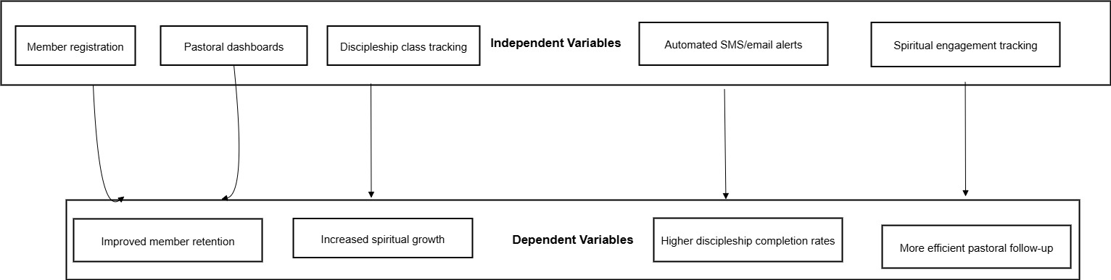
Figure 1: Concept Diagram

CHAPTER THREE

RESEARCH METHODOLOGY

3.1 Introduction
This chapter outlines the research and development methodologies used in designing and implementing the enhanced follow-up and discipleship for the digital age.. It describes the research approach, development strategy, data collection techniques, system analysis and design phases, and ethical considerations. The research employs a mixed-method approach combining both qualitative and quantitative methodologies, while the system development follows an Agile methodology for iterative and collaborative progress.

3.2 Research Methodology
The study employs a mixed-method research approach to gain comprehensive insights into the challenges of discipleship and follow-up within church environments. The qualitative component involves gathering detailed opinions and experiences from church leaders and members, while the quantitative component captures numerical data regarding attendance, retention rates, and follow-up efficiency.
This hybrid approach provides both the depth and breadth required for a thorough investigation, as recommended by Creswell (2021). Qualitative interviews offer context-specific insights, while surveys generate statistical evidence on trends and user feedback.

3.3 Development Methodology

3.3.1 Development Approach
This project adopts the Agile software development methodology, a framework chosen for its emphasis on incremental development and adaptability. This iterative process is perfectly suited for this project because it facilitates regular engagement with church leaders for continuous feedback. By building and refining modules progressively, frequent testing ensures the final product is highly responsive and precisely aligned with the ministry's specific user needs. According to Beck et al. (2020), Agile development improves responsiveness to changes and encourages user involvement, both critical in church-based solutions.

3.3.2 Iterative Process
Development will proceed in the following iterations:
- Requirement Analysis: Collect stakeholder needs and expectations.
- Prototype Development: Create low-fidelity wireframes and interactive models.
- Module Implementation: Code individual components (e.g., member registration, attendance tracking).
- Integration and Testing: Combine modules and conduct functionality and usability tests.
- Deployment and Feedback: Release the beta system to a sample church group and gather improvement suggestions.
Each iteration concludes with user validation to confirm that the objectives are being met progressively.

3.4 Data Collection Methods
Due to time constraints, secondary data collection is prioritized, including literature, church reports, and existing CMS documentation. However, the following primary data tools are also used:
- Interviews: Conducted with 2 pastors and 3 ministry leaders, and 4 church members to understand current processes.
- Questionnaires: Distributed to a sample of 4 church members to collect opinions on follow-up and discipleship.
- Document Review: Assessment of attendance records and discipleship training manuals from participating churches.
This triangulation method ensures a comprehensive and validated understanding of the current challenges and system expectations (Orodho, 2022).

3.5 System Analysis and Design (SAD)

3.5.1 System Analysis

Requirements Gathering
- Interviews: Collected needs from church administrators and discipleship coordinators.
- Questionnaires: Identified functionality priorities and bottlenecks from church members.
- Document Review: Analyzed physical attendance sheets and mentorship tracking templates.

Requirements Analysis
- Functional Requirements:
Functional requirements, which describe what the system must do, were identified as follows: a robust User Management module to securely register new converts and manage different roles (e.g., Admin, Pastor, Member) with varying permissions; a comprehensive Discipleship and Class Management feature to create, schedule, and track attendance for various discipleship classes ; an Automated Communication engine to send timely SMS or email notifications for class reminders, welcome messages, and follow-up prompts for absenteeism ; and an insightful Reporting Dashboard to provide church leaders with real-time visual summaries of key metrics like attendance trends, member engagement, and discipleship completion rates. These functions directly address user needs, such as a pastor wanting to "see a report of all mentorship sessions held this week" or a member wishing to "receive reminders about class sessions".
- Non-Functional Requirements:
Equally important are the non-functional requirements, which define how the system should operate. Security is paramount, necessitating secure login protocols, role-based access control, and the encryption of sensitive member data both in transit and at rest to ensure confidentiality. The system must exhibit high Reliability and Performance, with a target of 99% uptime to be consistently available for church operations and optimized to ensure fast load times. Usability is another critical factor; the interface must be intuitive and easy to use, requiring minimal training for volunteers and leaders who may have varying levels of technical proficiency. Finally, the system must be Scalable to accommodate the growth of the church, capable of handling an increasing number of members, classes, and data without degradation in performance.
- User Stories:
  - "As a pastor, I want to see a report of all mentorship sessions held this week."
  - "As a member, I want to receive reminders about class sessions."

Feasibility Study
A feasibility study was conducted to assess the viability of the project, confirming its practicality from multiple standpoints. From a technical perspective, the project is highly feasible as it leverages a standard and sustainable technology stack comprising PHP, MySQL, and JavaScript, for which development resources are readily available. The economic feasibility is also favorable, as the use of open-source technologies minimizes licensing costs, with the primary investment being the initial development time. Lastly, the project is operationally feasible because target churches already utilize basic digital tools like WhatsApp for communication, indicating a foundational level of digital literacy and a high likelihood of adopting the new system with minimal training and disruption to their existing processes.

3.5.2 System Modeling
Context Diagram
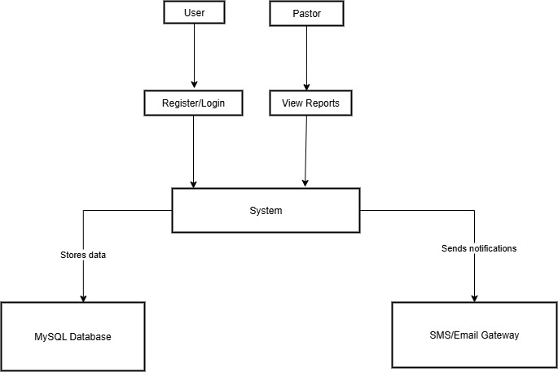
Figure 2: Context Diagram

Data Flow Diagram (D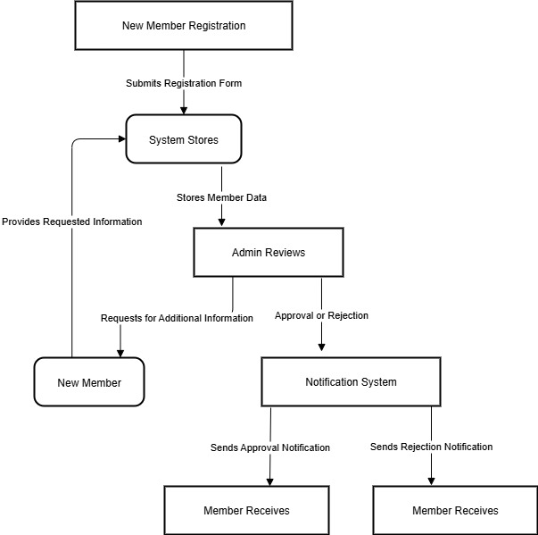
Figure 3: Data Flow Diagram

Entity Relationship Diagram (ERD)
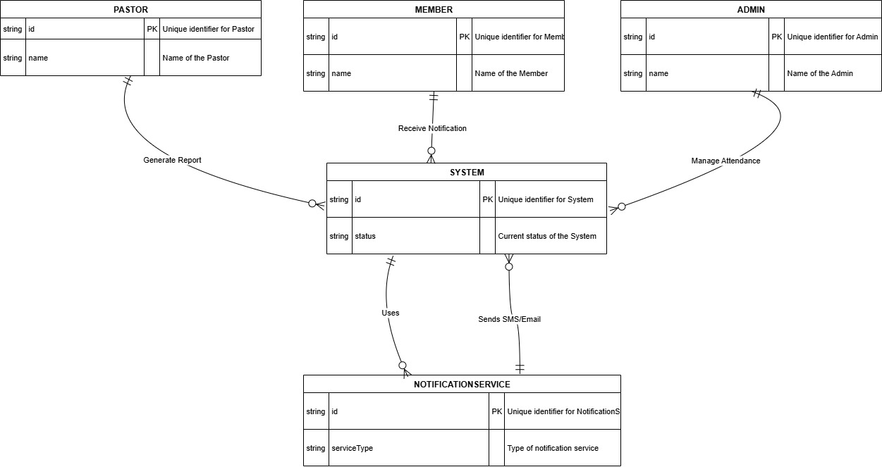
Figure 4: Entity Relationship Diagram

Use Case Diagram

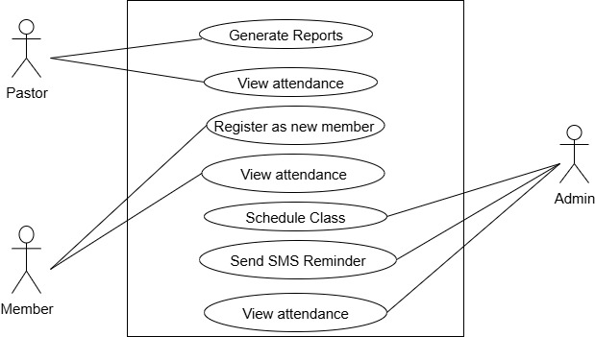

Figure 5: Use Case Diagram

Class Diagram

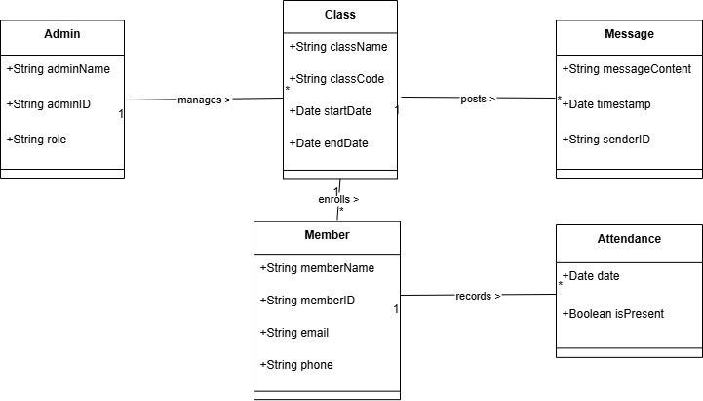
Figure 6: Class Diagram

Sequence Diagram

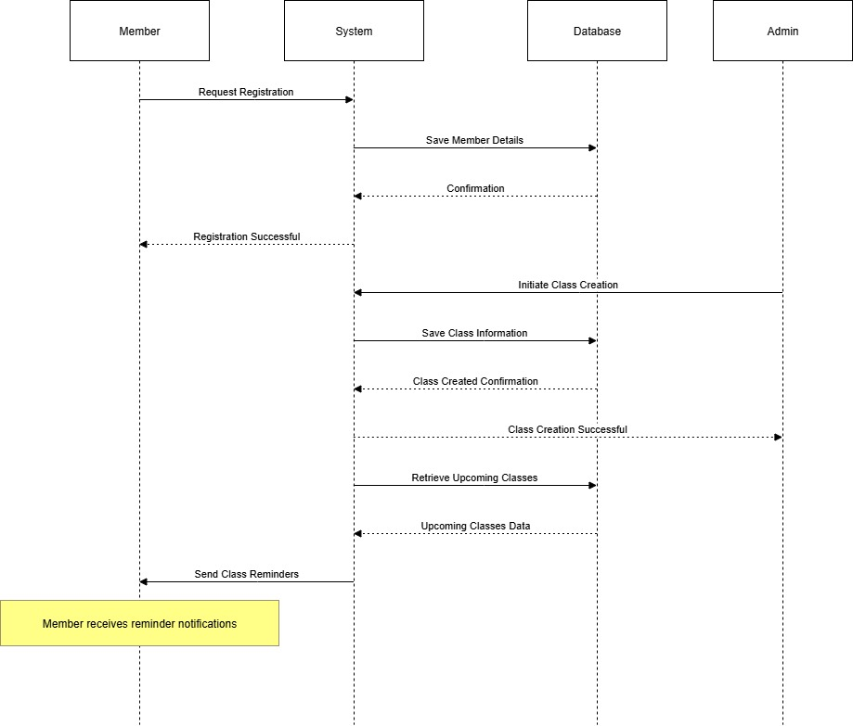
Figure 7: Sequence Diagram

Activity Diagram

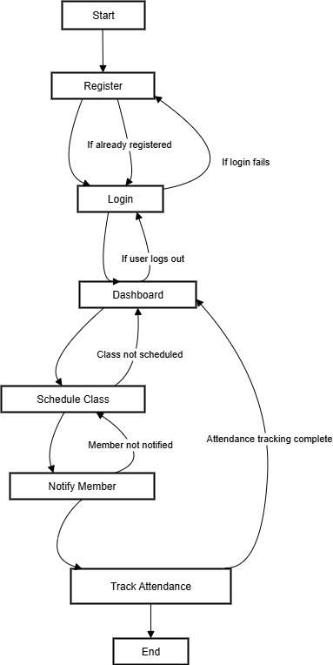
Figure 8: Activity Diagram

3.5.3 System Design

a. Architectural Design
The system is built upon a 3-tier architecture to ensure a clear separation of concerns and maintainability. The Presentation Layer, which serves as the user interface, is developed using HTML, CSS, and JavaScript, providing an interactive experience for church users. All core operations, such as class management, member tracking, and automated messaging, are handled by the Business Logic Layer, which is powered by PHP. Finally, the Data Layer consists of a MySQL database responsible for securely storing all essential information, including member records, attendance logs, and communication histories.

b. Component Design
The system's functionality is organized into several distinct but interconnected components designed for specific tasks. These include a registration module for enrolling new members, a class scheduling and attendance module to manage discipleship programs, a messaging engine to automate SMS and email communications, and a reporting module to generate insights for church leadership. Each component is designed to be loosely coupled, a strategic choice that simplifies maintenance and allows for future updates or modifications without affecting the entire system.

c. Database Design
The database schema is structured around five core tables: Members, Classes, Attendance, Messages, and Admins. This relational model is designed to efficiently manage the connections between users, their class activities, and all communications sent by the system. To ensure fast and responsive data retrieval, indexes will be implemented on foreign keys and timestamp fields, which is a critical step for optimizing query performance as the volume of data grows.

d. User Interface Design
The user interface (UI) is thoughtfully designed to be responsive and intuitive for use on both mobile and desktop devices. Key features include a clean navigation menu that provides easy access to the class schedule, attendance records, and reports. A central dashboard presents visual summaries of key metrics, allowing leaders to grasp important trends at a glance. Furthermore, user-friendly forms are provided for essential tasks like member registration and marking class attendance, simplifying data entry for all users.

e. Prototyping
The design process follows an iterative prototyping model to ensure the final product aligns with user needs. Initial concepts were visualized using low-fidelity wireframes, which helped outline the basic structure and flow of the system. These were later developed into interactive high-fidelity prototypes in Figma to simulate the complete user experience before coding began. Throughout this process, all technical specifications and design documents were consistently reviewed by project supervisors and validated against the requirements gathered from stakeholders to ensure alignment and functionality

3.6 Research Ethics
Ethical considerations included informed consent for all participants, anonymization of personal data, voluntary participation, and secure handling of all collected data. The research complied with academic and institutional ethical standards as defined by Babbie (2021). The development process ensured iterative reviews and validations to align with both user needs and academic requirements. The system is currently in the implementation phase with plans for pilot testing in a church located in Nakuru town.

3.7 REFERENCES
Barna Group. (2018). State of the Church Report. Barna Research.
Babbie, E. R. (2021). The Basics of Social Research. Cengage Learning.
Beck, K., et al. (2020). Manifesto for Agile Software Development. https://agilemanifesto.org
Creswell, J. W. (2021). Research Design: Qualitative, Quantitative, and Mixed Methods Approaches. SAGE Publications.
Karanja, S. (2022). Automation in Church Communication. Journal of Ministry Technology, 5(2), 35-47.
Mugambi, J. (2019). Church Management in the Digital Age. Nairobi: Grace Publishers.
Omondi, M. (2021). Limitations of Church Management Systems. East African Journal of ICT, 3(1), 14-22.
Orodho, J. A. (2022). Techniques of Writing Research Proposals and Reports in Education and Social Sciences. Kanezja Publishers.
Thompson, D. & Rao, P. (2017). Measuring Spiritual Growth: Frameworks for Digital Discipleship. Christian ICT Review, 4(3), 50-63.

APPENDICES

APPENDIX A: SAMPLE QUESTIONNAIRE
- How often do you attend discipleship classes?
  - Weekly
  - Monthly
  - Occasionally
- Do you receive follow-up communication after attending a church service or class?
  - Yes
  - No
- How helpful do you find the current discipleship process?
  - Very helpful
  - Somewhat helpful
  - Not helpful
- Would you be open to automated reminders (SMS/email) for follow-up?
  - Yes
  - No
- How do you prefer to receive follow-up communication from the church (e.g., call, SMS, email)?
  - Call
  - SMS
  - Email
- How would you rate your spiritual growth in the last six months?
  - Significant growth
  - Some growth
  - No change
  - Decline
- What new system feature would be most helpful to your spiritual development?
  - Tracking personal prayer goals
  - Connecting with a mentor
  - Receiving personalized Bible study plans
  - Accessing sermon notes and media

APPENDIX B: INTERVIEW GUIDE
Questions for Church Leaders (Pastors/Elders):
- What are the biggest challenges you currently face in ensuring new converts are effectively integrated into the church?
- Describe the current process your church uses to track an individual's journey from new believer to active member. What tools do you use?
- How do you currently measure the success or effectiveness of your discipleship programs?
- If you had a centralized digital system, what three key pieces of information would you want to see on a dashboard every week?
Questions for Ministry/Discipleship Coordinators:
- What are the day-to-day logistical challenges of managing discipleship classes (e.g., scheduling, communicating with members, tracking attendance)?
- How do you currently communicate with members about class schedules, cancellations, or follow-up materials? What works well and what doesn't?
- What difficulties do you encounter when trying to report attendance and progress to senior church leadership?
- What features in a digital tool would make your role in managing discipleship easier and more effective?
Questions for Church Members:
- After you first decided to join the church, what was the follow-up process like for you?
- How do you currently receive information about discipleship classes or small group meetings?
- Have you ever missed a class or meeting because you forgot or weren't reminded? How would you feel about receiving automated reminders via SMS or email?
- What kind of support or information would help you feel more connected and engaged in your spiritual growth at this church?

APPENDIX C : ESTIMATE BUDGET
ITEM | AMOUNTS (SHS)
PRINTING AND PHOTOCOPYING | 1000
TRANSPORT | 500
PAPERS (1 REAM) | 550
BINDING | 50
INTERNET | 1,000
TOTAL | 3100

APPENDIX D: WORK PLAN
ACTIVITIES | MONTH OF MAY-AUGUST
 | WEEKS
Weeks | 1 | 2 | 3 | 4 | 1 | 2 | 3 | 4 | 1 | 2
Proposal stage
Data analysis and proposal writing
System design
Implementation stage
Report writing

